How To Download & Analyze Previous Years’ Method Test Prep Usage

Method Test Prep stores historical usage information for you to analyze. It is a good practice to download the previous year’s usage information every summer after the Method Test Prep school year closes on July 15th. If you have not done this previously, all of your available data is waiting for you in the program.  As your school prepares to move to using our latest platform, Methodize, now would be a very good time to download your statistics from the Method Test Prep program.  To access your school’s past data navigate to the gray menu on the left and mouse over Reports. A new window will appear and list your report options. Please click on the Downloadable Reports option. | 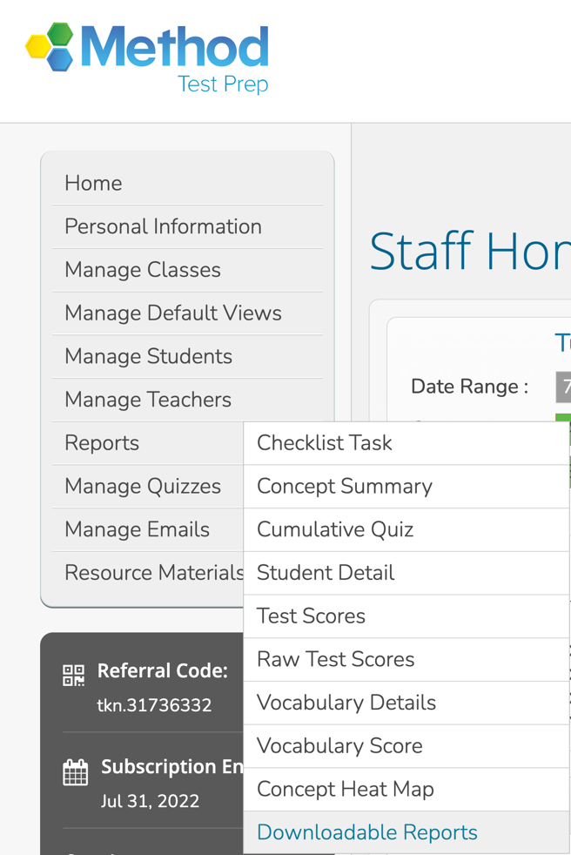
To see your students’ usage data for a previous year, select the Student Data report in Step 1. Note that this report works best for completed years—while you CAN download this year’s report, it may not be perfectly exact (it updates every day at 2am).  Once you’ve selected the report, please move on to step two and select your time frame. (We recommend not going back before 2016, as that is when the current ACT and SAT modules went into effect.)  Once you’ve chosen your report and set a time frame, please hit search. Your school report will appear directly below the step one and two menu, and you will have the option to download the Excel file. | 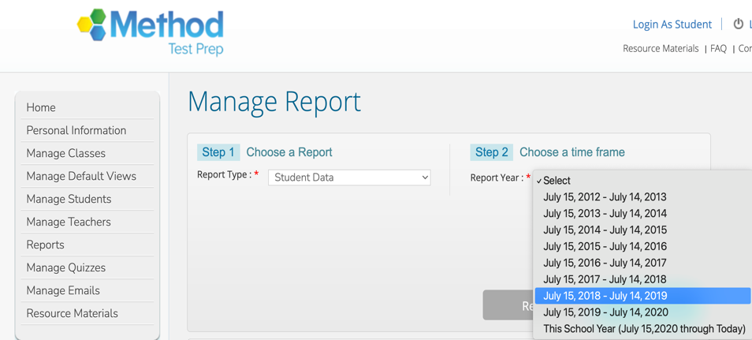
When downloading the file, be aware that the file extension will actually be a .CSV and not an .XLS - your computer may give you a warning before opening your downloaded report, please ignore this and continue to open your document. | 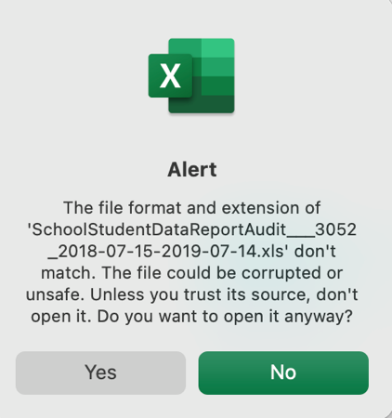
The downloaded report will let you see the following statistics:

- Total logins
- Last login
- Total questions answered
- % answered correctly/% answered incorrectly
- Number of vocabulary words mastered
- % complete

If you download multiple years of data, we suggest that you make each year a separate sheet in a workbook in your spreadsheet program of choice. Using simple formulae to sum the logins, questions answered, etc., will make it easy to compare year over year stats. Here is a glance at how the sheet might look after adding formulae (note that I have deleted some of the columns for this illustration):

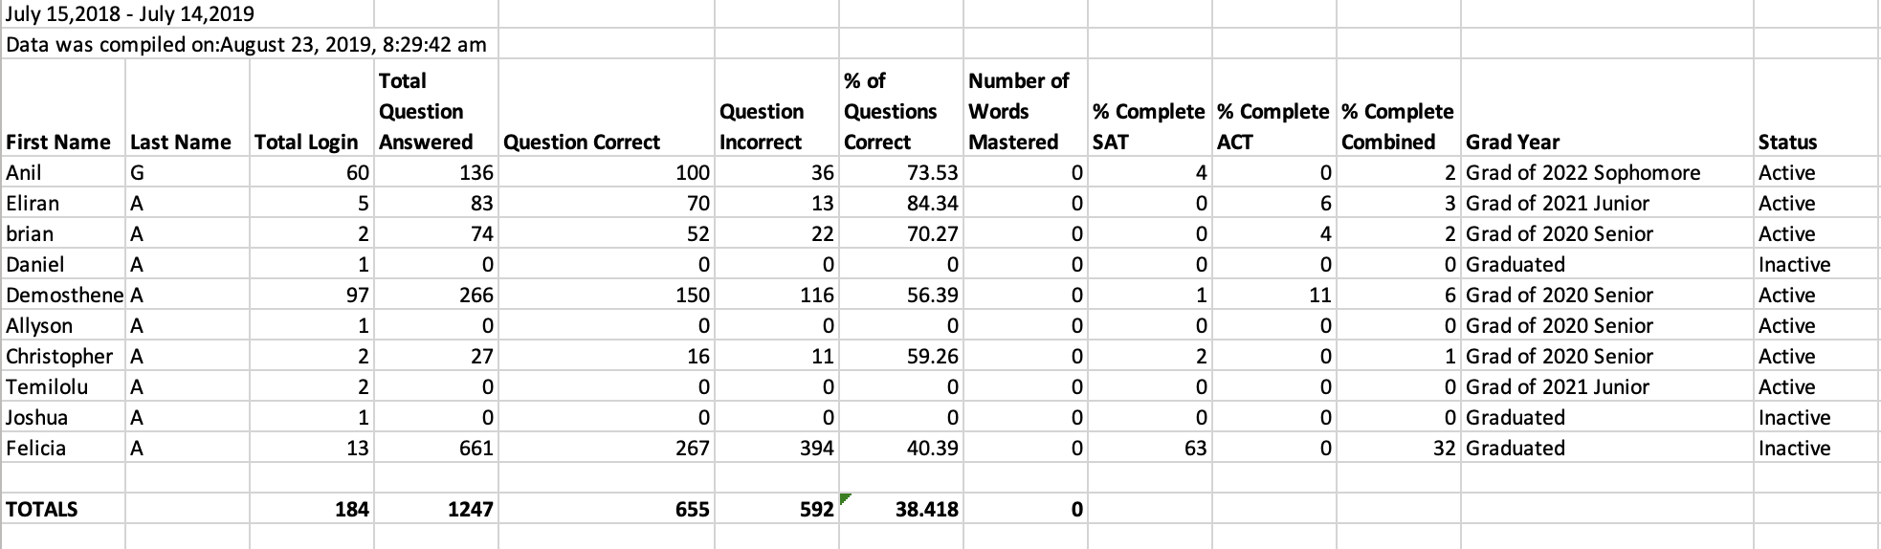

Should you need any other assistance, please contact support@methodlearning.com and we will be happy to assist you.

